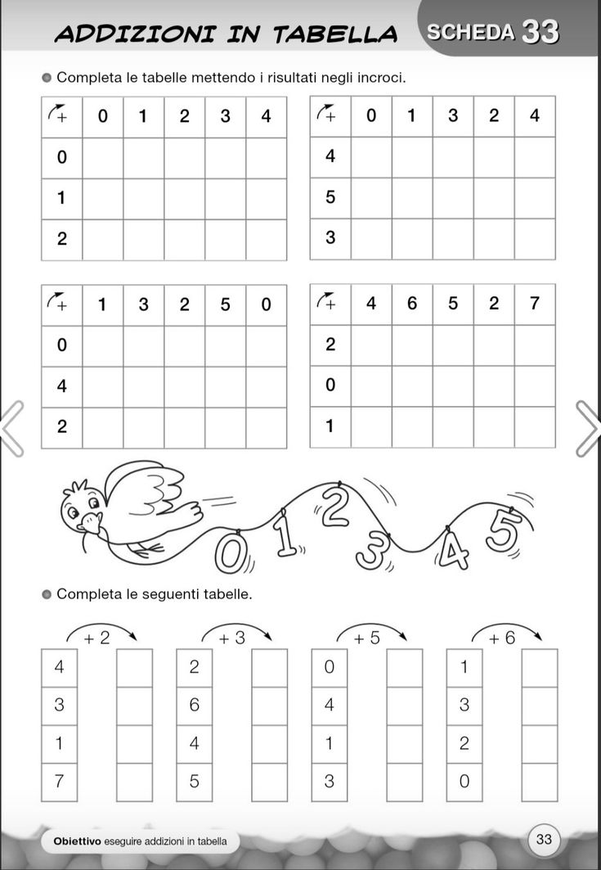

***2․ Հաշվի՛ր։***

***1․ Գտի՛ր օրինաչափությունը և լրացրո՛ւ դատարկ վանդակները։***

***3․ Հաշվի՛ր։***

|  |  |  |  |  |  |  |  |  |  |  |  |  |  |  |  |  |  |  |  |  |  |  |  |
| --- | --- | --- | --- | --- | --- | --- | --- | --- | --- | --- | --- | --- | --- | --- | --- | --- | --- | --- | --- | --- | --- | --- | --- |
| **2** | **+** | **5** | **+** | **2** | **=** |  |  | **8** | **-** | **2** | **-** | **3** | **=** |  |  | **5** | **-** | **2** | **+** | **3** | **=** |  |  |
|  |  |  |  |  |  |  |  |  |  |  |  |  |  |  |  |  |  |  |  |  |  |  |  |
| **5** | **+** | **2** | **+** | **2** | **=** |  |  | **4** | **-** | **2** | **-** | **2** | **=** |  |  | **7** | **-** | **2** | **+** | **2** | **=** |  |  |
|  |  |  |  |  |  |  |  |  |  |  |  |  |  |  |  |  |  |  |  |  |  |  |  |
| **3** | **+** | **4** | **+** | **2** | **=** |  |  | **9** | **-** | **3** | **-** | **1** | **=** |  |  | **4** | **-** | **3** | **+** | **1** | **=** |  |  |
|  |  |  |  |  |  |  |  |  |  |  |  |  |  |  |  |  |  |  |  |  |  |  |  |

4․ Հաշվի՛ր և ներկի՛ր։

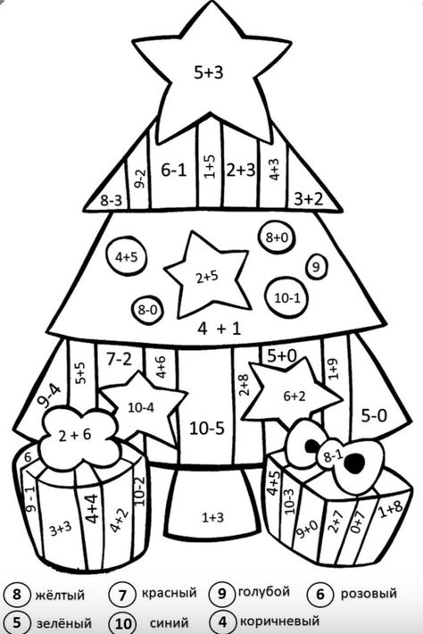

8 դեղին 7 կարմիր 9 երկնագույն 6 վարդագույն

5 կանաչ 10 կապույտ 4 շագանակագույն

***5․ Համեմատի՛ր: < > =***

|  |  |  |  |  |  |  |  |  |  |  |  |  |  |  |  |  |  |  |  |  |  |  |
| --- | --- | --- | --- | --- | --- | --- | --- | --- | --- | --- | --- | --- | --- | --- | --- | --- | --- | --- | --- | --- | --- | --- |
| 7 |  | 5 | + | 2 |  |  |  | 4 | + | 4 |  | 6 |  |  |  | 1 | + | 9 |  | 8 | + | 2 |
|  |  |  |  |  |  |  |  |  |  |  |  |  |  |  |  |  |  |  |  |  |  |  |
| 8 |  | 9 | - | 2 |  |  |  | 7 | - | 5 |  | 9 |  |  |  | 9 | - | 2 |  | 2 | + | 5 |
|  |  |  |  |  |  |  |  |  |  |  |  |  |  |  |  |  |  |  |  |  |  |  |
| 5 |  | 3 | + | 6 |  |  |  | 5 | + | 3 |  | 8 |  |  |  | 4 | + | 5 |  | 3 | + | 7 |

6․ Հիշի՛ր տրված թվերի կազմությունը և ներկի՛ր համապատասխան շրջանը։

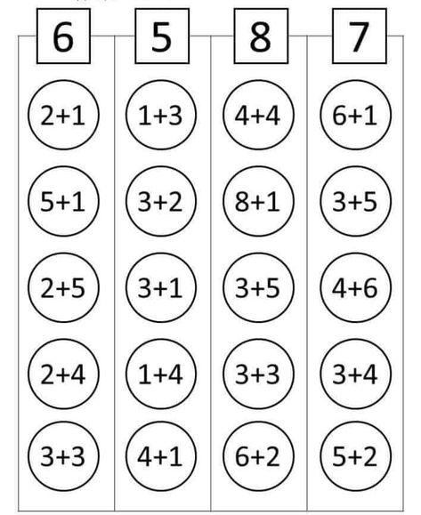

**7․ Գտի՛ր 10 տարբերություն։**

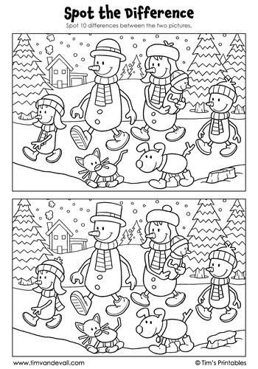

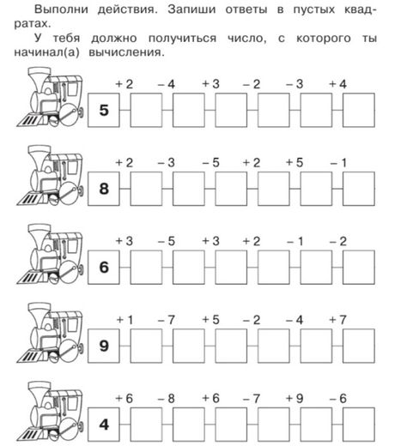

8․ Հաշվի՛ր և լրացրո՛ւ դատարկ վանդակները։

***9․ Ինքդ կազմի՛ր հավասարումներ և լուծի՛ր:***

|  |  |  |  |  |  |  |  |  |  |  |  |  |  |  |  |  |  |  |  |  |  |  |  |  |  |  |  |  |  |
| --- | --- | --- | --- | --- | --- | --- | --- | --- | --- | --- | --- | --- | --- | --- | --- | --- | --- | --- | --- | --- | --- | --- | --- | --- | --- | --- | --- | --- | --- |
|  |  |  |  |  |  |  |  |  |  |  |  |  |  |  |  |  |  |  |  |  |  |  |  |  |  |  |  |  |  |
|  |  |  |  |  |  |  |  |  |  |  |  |  |  |  |  |  |  |  |  |  |  |  |  |  |  |  |  |  |  |
|  |  |  |  |  |  |  |  |  |  |  |  |  |  |  |  |  |  |  |  |  |  |  |  |  |  |  |  |  |  |
|  |  |  |  |  |  |  |  |  |  |  |  |  |  |  |  |  |  |  |  |  |  |  |  |  |  |  |  |  |  |
|  |  |  |  |  |  |  |  |  |  |  |  |  |  |  |  |  |  |  |  |  |  |  |  |  |  |  |  |  |  |
|  |  |  |  |  |  |  |  |  |  |  |  |  |  |  |  |  |  |  |  |  |  |  |  |  |  |  |  |  |  |
|  |  |  |  |  |  |  |  |  |  |  |  |  |  |  |  |  |  |  |  |  |  |  |  |  |  |  |  |  |  |
|  |  |  |  |  |  |  |  |  |  |  |  |  |  |  |  |  |  |  |  |  |  |  |  |  |  |  |  |  |  |
|  |  |  |  |  |  |  |  |  |  |  |  |  |  |  |  |  |  |  |  |  |  |  |  |  |  |  |  |  |  |
|  |  |  |  |  |  |  |  |  |  |  |  |  |  |  |  |  |  |  |  |  |  |  |  |  |  |  |  |  |  |
|  |  |  |  |  |  |  |  |  |  |  |  |  |  |  |  |  |  |  |  |  |  |  |  |  |  |  |  |  |  |
|  |  |  |  |  |  |  |  |  |  |  |  |  |  |  |  |  |  |  |  |  |  |  |  |  |  |  |  |  |  |
|  |  |  |  |  |  |  |  |  |  |  |  |  |  |  |  |  |  |  |  |  |  |  |  |  |  |  |  |  |  |

***10․ Հաշվի՛ր։***

|  |  |  |  |  |  |  |  |  |  |  |  |  |  |  |  |  |  |  |  |  |  |  |  |  |  |  |  |  |
| --- | --- | --- | --- | --- | --- | --- | --- | --- | --- | --- | --- | --- | --- | --- | --- | --- | --- | --- | --- | --- | --- | --- | --- | --- | --- | --- | --- | --- |
| 5 | + | 3 | + | 1 | = |  |  |  | 9 | - | 4 | + | 4 | = |  |  |  | 1 | 0 | - | 5 | + | 2 | = |  |  |  |  |
|  |  |  |  |  |  |  |  |  |  |  |  |  |  |  |  |  |  |  |  |  |  |  |  |  |  |  |  |  |
| 8 | - | 1 | - | 2 | = |  |  |  | 4 | + | 2 | - | 1 | = |  |  |  | 1 | 0 | - | 9 | + | 5 | = |  |  |  |  |
|  |  |  |  |  |  |  |  |  |  |  |  |  |  |  |  |  |  |  |  |  |  |  |  |  |  |  |  |  |
| 3 | + | 3 | + | 4 | = |  |  |  | 4 | - | 2 | + | 7 | = |  |  |  | 1 | 0 | - | 4 | + | 3 | = |  |  |  |  |
|  |  |  |  |  |  |  |  |  |  |  |  |  |  |  |  |  |  |  |  |  |  |  |  |  |  |  |  |  |
| 8 | - | 3 | - | 2 | = |  |  |  | 7 | - | 3 | + | 3 | = |  |  |  | 1 | 0 | - | 6 | + | 5 | = |  |  |  |  |
|  |  |  |  |  |  |  |  |  |  |  |  |  |  |  |  |  |  |  |  |  |  |  |  |  |  |  |  |  |
| 4 | + | 2 | + | 3 | = |  |  |  | 7 | + | 3 | - | 4 | = |  |  |  | 1 | 0 | - | 3 | + | 2 | = |  |  |  |  |
|  |  |  |  |  |  |  |  |  |  |  |  |  |  |  |  |  |  |  |  |  |  |  |  |  |  |  |  |  |
| 9 | - | 2 | - | 2 | = |  |  |  | 5 | + | 5 | - | 6 | = |  |  |  | 1 | 0 | - | 7 | - | 1 | = |  |  |  |  |
|  |  |  |  |  |  |  |  |  |  |  |  |  |  |  |  |  |  |  |  |  |  |  |  |  |  |  |  |  |
| 7 | + | 1 | + | 2 | = |  |  |  | 5 | + | 3 | - | 8 | = |  |  |  | 1 | 0 | - | 8 | - | 2 | = |  |  |  |  |
|  |  |  |  |  |  |  |  |  |  |  |  |  |  |  |  |  |  |  |  |  |  |  |  |  |  |  |  |  |
| 8 | - | 3 | - | 3 | = |  |  |  | 3 | + | 6 | - | 5 | = |  |  |  | 1 | 0 | - | 1 | - | 6 | = |  |  |  |  |
|  |  |  |  |  |  |  |  |  |  |  |  |  |  |  |  |  |  |  |  |  |  |  |  |  |  |  |  |  |
| 5 | + | 2 | + | 2 | = |  |  |  | 6 | - | 4 | + | 8 | = |  |  |  | 1 | 0 | - | 2 | - | 4 | = |  |  |  |  |

11․ Լուծի՛ր սուդոկուները։

|  |  |  |  |
| --- | --- | --- | --- |
| 4 |  | 2 | 3 |
|  | 3 |  | 1 |
| 1 |  | 3 |  |
| 3 | 4 |  | 2 |

|  |  |  |  |
| --- | --- | --- | --- |
|  |  | 2 | 3 |
| 3 | 2 |  | 4 |
| 2 |  | 4 | 1 |
| 1 | 4 |  |  |