1. **Հաշվի՛ր:**

|  |  |  |  |  |  |  |  |  |  |  |  |  |  |  |  |  |  |  |  |  |  |  |
| --- | --- | --- | --- | --- | --- | --- | --- | --- | --- | --- | --- | --- | --- | --- | --- | --- | --- | --- | --- | --- | --- | --- |
| 2 | + | 6 | = |  |  |  |  | 1 | + | 7 | = |  |  |  |  | 8 | - | 6 | = |  |  |  |
|  |  |  |  |  |  |  |  |  |  |  |  |  |  |  |  |  |  |  |  |  |  |  |
| 6 | + | 2 | = |  |  |  |  | 7 | + | 1 | = |  |  |  |  | 8 | - | 3 | = |  |  |  |
|  |  |  |  |  |  |  |  |  |  |  |  |  |  |  |  |  |  |  |  |  |  |  |
| 3 | + | 5 | = |  |  |  |  | 3 | + | 3 | = |  |  |  |  | 8 | - | 4 | = |  |  |  |
|  |  |  |  |  |  |  |  |  |  |  |  |  |  |  |  |  |  |  |  |  |  |  |
| 5 | + | 3 | = |  |  |  |  | 2 | + | 3 | = |  |  |  |  | 7 | - | 4 | = |  |  |  |
|  |  |  |  |  |  |  |  |  |  |  |  |  |  |  |  |  |  |  |  |  |  |  |
| 3 | + | 4 | = |  |  |  |  | 1 | + | 5 | = |  |  |  |  | 7 | - | 1 | = |  |  |  |
|  |  |  |  |  |  |  |  |  |  |  |  |  |  |  |  |  |  |  |  |  |  |  |
| 4 | + | 4 | = |  |  |  |  | 5 | + | 0 | = |  |  |  |  | 7 | - | 5 | = |  |  |  |

1. **Համեմատի՛ր: < > =**

|  |  |  |  |  |  |  |  |  |  |  |  |  |  |  |  |  |  |  |  |  |  |  |
| --- | --- | --- | --- | --- | --- | --- | --- | --- | --- | --- | --- | --- | --- | --- | --- | --- | --- | --- | --- | --- | --- | --- |
| 3 | + | 5 |  | 4 | + | 4 |  |  |  | 6 | + | 2 |  | 4 | + | 4 |  |  |  | 5 |  | 8 |
|  |  |  |  |  |  |  |  |  |  |  |  |  |  |  |  |  |  |  |  |  |  |  |
| 8 | - | 3 |  | 3 | + | 2 |  |  |  | 5 | - | 3 |  | 8 | - | 3 |  |  |  | 6 |  | 8 |
|  |  |  |  |  |  |  |  |  |  |  |  |  |  |  |  |  |  |  |  |  |  |  |
| 3 | + | 4 |  | 5 | + | 2 |  |  |  | 2 | + | 4 |  | 4 | + | 2 |  |  |  | 8 |  | 2 |
|  |  |  |  |  |  |  |  |  |  |  |  |  |  |  |  |  |  |  |  |  |  |  |
| 6 | - | 2 |  | 8 | - | 4 |  |  |  | 8 | - | 4 |  | 8 | - | 5 |  |  |  | 7 |  | 3 |

1. **Գտի՛ր պակասող թվերը:**

|  |  |  |  |  |  |  |  |  |  |  |  |  |  |  |  |  |  |  |  |  |  |  |  |
| --- | --- | --- | --- | --- | --- | --- | --- | --- | --- | --- | --- | --- | --- | --- | --- | --- | --- | --- | --- | --- | --- | --- | --- |
| 3 | + |  | = | 4 |  |  |  | 5 | + |  | = | 8 |  |  |  |  | + | 2 | = | 4 |  |  |  |
|  |  |  |  |  |  |  |  |  |  |  |  |  |  |  |  |  |  |  |  |  |  |  |  |
| 8 | - |  | = | 7 |  |  |  |  | - | 6 | = | 2 |  |  |  |  | - | 3 | = | 2 |  |  |  |
|  |  |  |  |  |  |  |  |  |  |  |  |  |  |  |  |  |  |  |  |  |  |  |  |
|  | + | 4 | = | 7 |  |  |  | 5 | + |  | = | 7 |  |  |  | 6 | + |  | = | 8 |  |  |  |
|  |  |  |  |  |  |  |  |  |  |  |  |  |  |  |  |  |  |  |  |  |  |  |  |
|  | - | 5 | = | 3 |  |  |  |  | - | 4 | = | 2 |  |  |  | 7 | - |  | = | 1 |  |  |  |

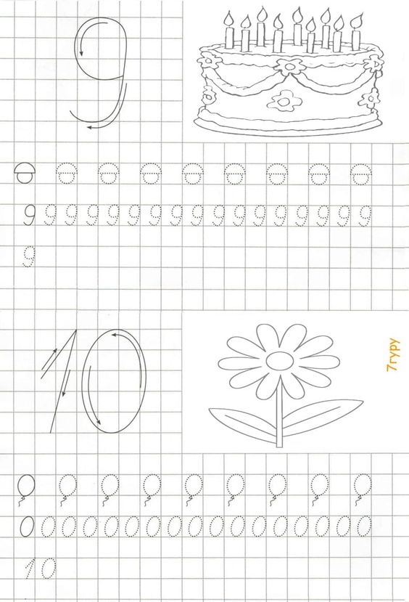

1. **Լրացրո՛ւ աղյուսակը:**

|  |  |  |  |  |  |  |
| --- | --- | --- | --- | --- | --- | --- |
| + | 0 | 1 | 2 | 3 | 4 | 5 |
| 2 |  |  |  |  |  | 7 |
| 4 | 4 |  |  | 7 |  |  |
| 0 |  |  |  |  |  |  |
| 5 |  | 6 |  |  |  |  |
| 1 |  |  | 3 |  |  |  |
| 3 |  |  |  |  | 7 |  |

**5․ Լրացրո՛ւ աղյուսակը:**

|  |  |  |
| --- | --- | --- |
| Նախորդ | Թիվ | Հաջորդ |
|  | 7 |  |
|  | 6 |  |
|  | 3 |  |
|  | 9 |  |
|  | 4 |  |
|  | 2 |  |
|  | 8 |  |
|  | 5 |  |

6․ Լուծի՛ր խնդիրը։

Անին ունի 5 մատիտ, իսկ Գայանեն 3 մատիտ: Քանի՞ մատիտ ունեն աղջիկները:

|  |  |  |  |  |
| --- | --- | --- | --- | --- |
|  |  |  |  |  |

Լուծում

|  |
| --- |
|  |

Պատասխան

**7․ Գտի՛ր պակասող թվերը:**

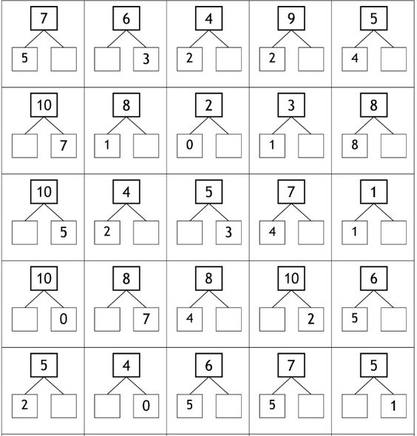

**8․ Գտի՛ր տնակի բնակիչներին:**

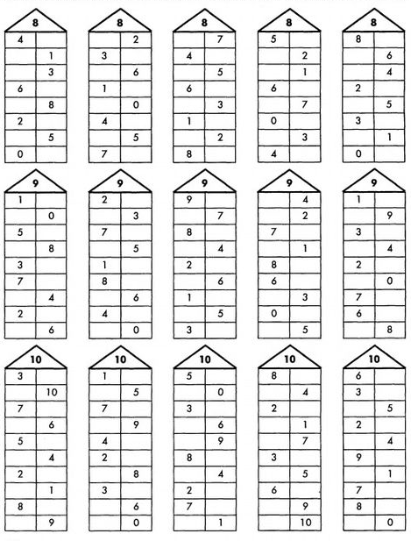

9․ Հաշվի՛ր:

|  |  |  |  |  |  |  |  |  |  |  |  |  |  |  |  |  |  |  |  |  |  |
| --- | --- | --- | --- | --- | --- | --- | --- | --- | --- | --- | --- | --- | --- | --- | --- | --- | --- | --- | --- | --- | --- |
| 2 | + | 6 | = |  |  |  |  | 4 | - | 3 | = |  |  |  |  | 4 | + | 5 | = |  |  |
|  |  |  |  |  |  |  |  |  |  |  |  |  |  |  |  |  |  |  |  |  |  |
| 7 | + | 3 | = |  |  |  |  | 6 | - | 4 | = |  |  |  |  | 6 | - | 4 | = |  |  |
|  |  |  |  |  |  |  |  |  |  |  |  |  |  |  |  |  |  |  |  |  |  |
| 4 | + | 5 | = |  |  |  |  | 9 | - | 5 | = |  |  |  |  | 9 | - | 8 | = |  |  |
|  |  |  |  |  |  |  |  |  |  |  |  |  |  |  |  |  |  |  |  |  |  |
| 1 | + | 7 | = |  |  |  |  | 8 | - | 6 | = |  |  |  |  | 8 | - | 5 | = |  |  |
|  |  |  |  |  |  |  |  |  |  |  |  |  |  |  |  |  |  |  |  |  |  |
| 3 | + | 5 | = |  |  |  |  | 6 | - | 6 | = |  |  |  |  | 2 | - | 2 | = |  |  |

10․ Համեմատի՛ր: < > =

|  |  |  |  |  |  |  |  |  |  |  |  |  |  |  |  |  |  |  |  |  |  |  |
| --- | --- | --- | --- | --- | --- | --- | --- | --- | --- | --- | --- | --- | --- | --- | --- | --- | --- | --- | --- | --- | --- | --- |
| 2 |  | 2 | + | 2 |  |  |  | 4 | + | 2 |  | 6 |  |  |  | 7 | + | 3 |  | 8 | + | 2 |
|  |  |  |  |  |  |  |  |  |  |  |  |  |  |  |  |  |  |  |  |  |  |  |
| 4 |  | 7 | - | 6 |  |  |  | 7 | - | 1 |  | 9 |  |  |  | 4 | - | 2 |  | 9 | - | 6 |
|  |  |  |  |  |  |  |  |  |  |  |  |  |  |  |  |  |  |  |  |  |  |  |
| 9 |  | 3 | + | 6 |  |  |  | 5 | + | 3 |  | 6 |  |  |  | 4 | + | 5 |  | 3 | + | 7 |
|  |  |  |  |  |  |  |  |  |  |  |  |  |  |  |  |  |  |  |  |  |  |  |
| 6 |  | 0 | + | 7 |  |  |  | 9 | - | 7 |  | 9 |  |  |  | 2 | + | 3 |  | 8 | - | 4 |
|  |  |  |  |  |  |  |  |  |  |  |  |  |  |  |  |  |  |  |  |  |  |  |
| 5 |  | 9 | - | 4 |  |  |  | 7 | + | 2 |  | 9 |  |  |  | 7 | - | 2 |  | 1 | + | 3 |