Հաշվի՛ր:

|  |  |  |  |  |  |  |  |  |  |  |  |  |  |  |
| --- | --- | --- | --- | --- | --- | --- | --- | --- | --- | --- | --- | --- | --- | --- |
|  |  |  |  |  |  |  |  |  |  |  |  |  |  |  |
| 1 | + | 4 | = |  |  |  | 5 | - | 2 | = |  |  |  |  |
|  |  |  |  |  |  |  |  |  |  |  |  |  |  |  |
| 3 | + | 2 | = |  |  |  | 5 | - | 1 | = |  |  |  |  |
|  |  |  |  |  |  |  |  |  |  |  |  |  |  |  |
| 2 | + | 3 | = |  |  |  | 5 | - | 4 | = |  |  |  |  |
|  |  |  |  |  |  |  |  |  |  |  |  |  |  |  |
| 4 | + | 1 | = |  |  |  | 5 | - | 3 | = |  |  |  |  |

|  |  |  |  |  |  |  |  |  |  |  |  |  |  |  |
| --- | --- | --- | --- | --- | --- | --- | --- | --- | --- | --- | --- | --- | --- | --- |
|  |  |  |  |  |  |  |  |  |  |  |  |  |  |  |
| 1 | + | 5 | = |  |  |  | 6 | - | 4 | = |  |  |  |  |
|  |  |  |  |  |  |  |  |  |  |  |  |  |  |  |
| 2 | + | 4 | = |  |  |  | 6 | - | 5 | = |  |  |  |  |
|  |  |  |  |  |  |  |  |  |  |  |  |  |  |  |
| 3 | + | 3 | = |  |  |  | 6 | - | 3 | = |  |  |  |  |
|  |  |  |  |  |  |  |  |  |  |  |  |  |  |  |
| 4 | + | 2 | = |  |  |  | 6 | - | 1 | = |  |  |  |  |
|  |  |  |  |  |  |  |  |  |  |  |  |  |  |  |
| 5 | + | 1 | = |  |  |  | 6 | - | 2 | = |  |  |  |  |

Հաշվի՛ր։

|  |  |  |  |  |  |  |  |  |  |  |  |  |  |  |  |  |  |  |  |  |  |  |
| --- | --- | --- | --- | --- | --- | --- | --- | --- | --- | --- | --- | --- | --- | --- | --- | --- | --- | --- | --- | --- | --- | --- |
| 2 | + | 4 | = |  |  |  |  | 5 | - | 3 | = |  |  |  |  | 1 | + | 4 | = |  |  |  |
|  |  |  |  |  |  |  |  |  |  |  |  |  |  |  |  |  |  |  |  |  |  |  |
| 3 | + | 3 | = |  |  |  |  | 6 | - | 2 | = |  |  |  |  | 1 | + | 3 | = |  |  |  |
|  |  |  |  |  |  |  |  |  |  |  |  |  |  |  |  |  |  |  |  |  |  |  |
| 2 | + | 4 | = |  |  |  |  | 4 | - | 1 | = |  |  |  |  | 3 | + | 3 | = |  |  |  |
|  |  |  |  |  |  |  |  |  |  |  |  |  |  |  |  |  |  |  |  |  |  |  |

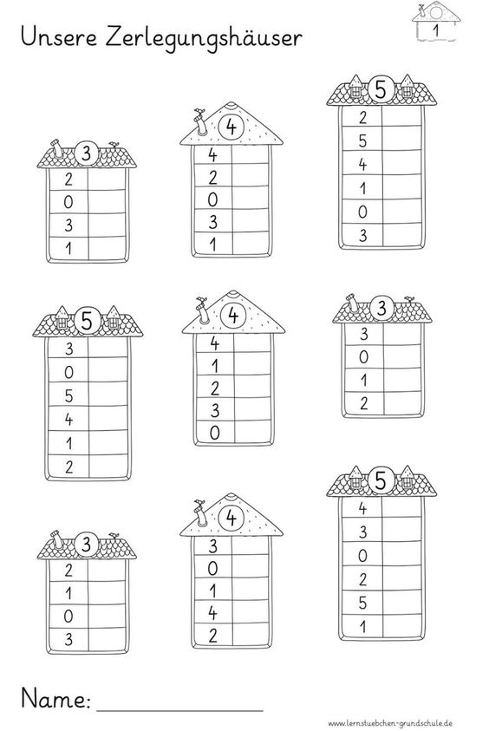

Տնակի բնակիչները մոլորվել են, օգնի՛ր գտնել իրենց տունը։

Գտի՛ր թաքնված թիվը։

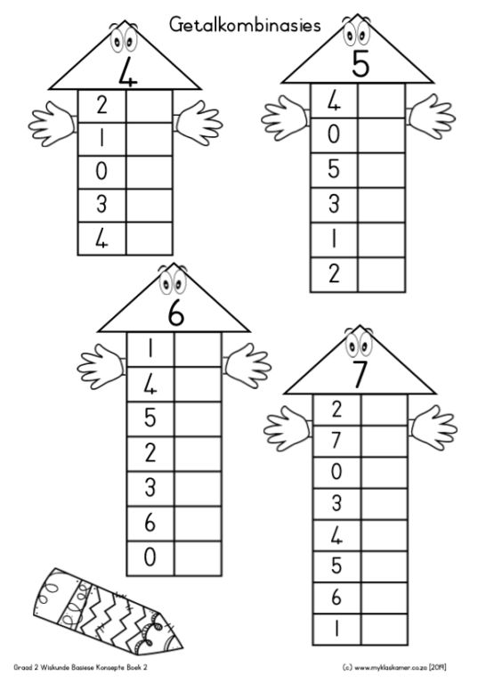

Հաշվի՛ր:

|  |  |  |  |  |  |  |  |  |  |  |  |  |  |  |
| --- | --- | --- | --- | --- | --- | --- | --- | --- | --- | --- | --- | --- | --- | --- |
|  |  |  |  |  |  |  |  |  |  |  |  |  |  |  |
| 1 | + | 1 | = |  |  |  | 1 | + | 2 | = |  |  |  |  |
|  |  |  |  |  |  |  |  |  |  |  |  |  |  |  |
| 2 | + | 2 | = |  |  |  | 3 | + | 3 | = |  |  |  |  |
|  |  |  |  |  |  |  |  |  |  |  |  |  |  |  |
| 3 | + | 2 | = |  |  |  | 4 | + | 2 | = |  |  |  |  |
|  |  |  |  |  |  |  |  |  |  |  |  |  |  |  |
| 4 | + | 1 | = |  |  |  | 2 | + | 3 | = |  |  |  |  |

|  |  |  |  |  |  |  |  |  |  |  |  |  |  |  |
| --- | --- | --- | --- | --- | --- | --- | --- | --- | --- | --- | --- | --- | --- | --- |
|  |  |  |  |  |  |  |  |  |  |  |  |  |  |  |
| 6 | - | 5 | = |  |  |  | 3 | - | 1 | = |  |  |  |  |
|  |  |  |  |  |  |  |  |  |  |  |  |  |  |  |
| 4 | - | 2 | = |  |  |  | 5 | - | 2 | = |  |  |  |  |
|  |  |  |  |  |  |  |  |  |  |  |  |  |  |  |
| 3 | - | 1 | = |  |  |  | 6 | - | 3 | = |  |  |  |  |
|  |  |  |  |  |  |  |  |  |  |  |  |  |  |  |
| 6 | - | 2 | = |  |  |  | 5 | - | 4 | = |  |  |  |  |
|  |  |  |  |  |  |  |  |  |  |  |  |  |  |  |
| 5 | - | 1 | = |  |  |  | 5 | - | 2 | = |  |  |  |  |

Հաշվի՛ր։

|  |  |  |  |  |  |  |  |  |  |  |  |  |  |  |  |  |  |  |  |  |  |  |
| --- | --- | --- | --- | --- | --- | --- | --- | --- | --- | --- | --- | --- | --- | --- | --- | --- | --- | --- | --- | --- | --- | --- |
| 4 | + | 2 | = |  |  |  |  | 5 | - | 3 | = |  |  |  |  | 5 | - | 4 | = |  |  |  |
|  |  |  |  |  |  |  |  |  |  |  |  |  |  |  |  |  |  |  |  |  |  |  |
| 3 | + | 2 | = |  |  |  |  | 6 | - | 2 | = |  |  |  |  | 1 | + | 3 | = |  |  |  |
|  |  |  |  |  |  |  |  |  |  |  |  |  |  |  |  |  |  |  |  |  |  |  |
| 2 | + | 2 | = |  |  |  |  | 4 | - | 1 | = |  |  |  |  | 6 | - | 3 | = |  |  |  |
|  |  |  |  |  |  |  |  |  |  |  |  |  |  |  |  |  |  |  |  |  |  |  |

Դատարկ վանդակները լրացրո՛ւ։

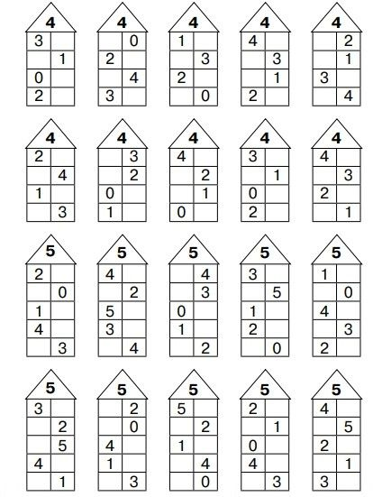

Համեմատի՛ր: > < =

|  |  |  |  |  |  |  |  |  |  |  |  |  |  |  |  |  |  |  |  |  |  |  |  |  |
| --- | --- | --- | --- | --- | --- | --- | --- | --- | --- | --- | --- | --- | --- | --- | --- | --- | --- | --- | --- | --- | --- | --- | --- | --- |
| 3 |  | 5 |  |  |  | 5 |  | 4 |  |  |  | 6 |  | 3 |  |  |  | 2 | + | 1 |  | 4 | - | 1 |
|  |  |  |  |  |  |  |  |  |  |  |  |  |  |  |  |  |  |  |  |  |  |  |  |  |
| 2 |  | 6 |  |  |  | 4 |  | 3 |  |  |  | 3 |  | 5 |  |  |  | 5 | - | 3 |  | 1 | + | 1 |

|  |  |  |  |  |  |  |  |  |  |  |  |  |  |  |  |  |  |  |  |  |  |  |  |  |
| --- | --- | --- | --- | --- | --- | --- | --- | --- | --- | --- | --- | --- | --- | --- | --- | --- | --- | --- | --- | --- | --- | --- | --- | --- |
| 1 |  | 4 |  |  |  | 5 |  | 4 |  |  |  | 6 |  | 2 |  |  |  | 2 | + | 2 |  | 3 | + | 1 |
|  |  |  |  |  |  |  |  |  |  |  |  |  |  |  |  |  |  |  |  |  |  |  |  |  |
| 2 |  | 1 |  |  |  | 1 |  | 3 |  |  |  | 5 |  | 5 |  |  |  | 5 | - | 2 |  | 1 | + | 2 |

|  |  |  |  |  |  |  |  |  |  |  |  |  |  |  |  |  |  |  |  |  |  |  |  |  |
| --- | --- | --- | --- | --- | --- | --- | --- | --- | --- | --- | --- | --- | --- | --- | --- | --- | --- | --- | --- | --- | --- | --- | --- | --- |
| 4 |  | 5 |  |  |  | 5 |  | 1 |  |  |  | 4 |  | 2 |  |  |  | 2 | + | 4 |  | 3 | + | 6 |
|  |  |  |  |  |  |  |  |  |  |  |  |  |  |  |  |  |  |  |  |  |  |  |  |  |
| 2 |  | 4 |  |  |  | 6 |  | 3 |  |  |  | 2 |  | 5 |  |  |  | 5 | - | 2 |  | 6 | - | 3 |

Հաշվի՛ր։

|  |  |  |  |  |  |  |  |  |  |  |  |  |  |  |  |  |  |  |  |  |  |  |
| --- | --- | --- | --- | --- | --- | --- | --- | --- | --- | --- | --- | --- | --- | --- | --- | --- | --- | --- | --- | --- | --- | --- |
| 2 | + | 2 | = |  |  |  |  | 5 | - | 2 | = |  |  |  |  | 5 | - | 4 | = |  |  |  |
|  |  |  |  |  |  |  |  |  |  |  |  |  |  |  |  |  |  |  |  |  |  |  |
| 3 | + | 3 | = |  |  |  |  | 4 | - | 2 | = |  |  |  |  | 5 | - | 3 | = |  |  |  |
|  |  |  |  |  |  |  |  |  |  |  |  |  |  |  |  |  |  |  |  |  |  |  |
| 2 | + | 4 | = |  |  |  |  | 4 | - | 1 | = |  |  |  |  | 6 | - | 3 | = |  |  |  |
|  |  |  |  |  |  |  |  |  |  |  |  |  |  |  |  |  |  |  |  |  |  |  |

Հաշվի՛ր։

|  |  |  |  |  |  |  |  |  |  |  |  |  |  |  |  |  |  |  |  |  |  |  |
| --- | --- | --- | --- | --- | --- | --- | --- | --- | --- | --- | --- | --- | --- | --- | --- | --- | --- | --- | --- | --- | --- | --- |
| 3 | + | 2 | = |  |  |  |  | 3 | + | 3 | = |  |  |  |  | 5 | - | 4 | = |  |  |  |
|  |  |  |  |  |  |  |  |  |  |  |  |  |  |  |  |  |  |  |  |  |  |  |
| 1 | + | 2 | = |  |  |  |  | 4 | + | 2 | = |  |  |  |  | 6 | - | 3 | = |  |  |  |
|  |  |  |  |  |  |  |  |  |  |  |  |  |  |  |  |  |  |  |  |  |  |  |

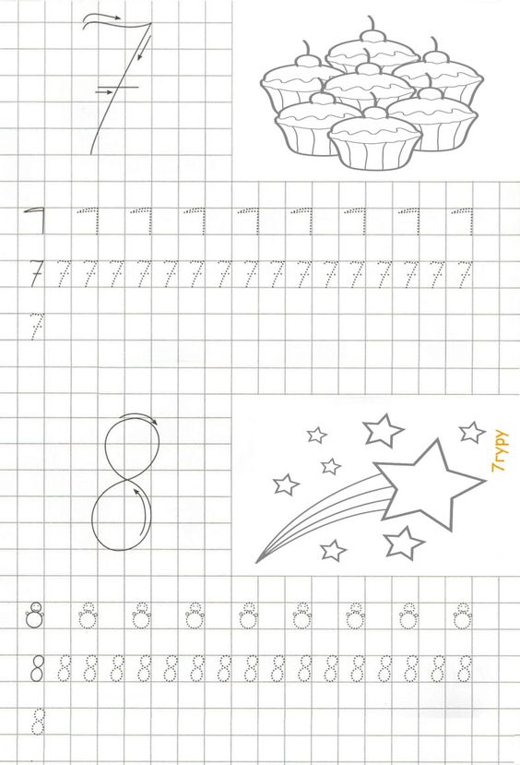

Հաշվի՛ր:

|  |  |  |  |  |  |  |  |  |  |  |  |  |  |  |
| --- | --- | --- | --- | --- | --- | --- | --- | --- | --- | --- | --- | --- | --- | --- |
|  |  |  |  |  |  |  |  |  |  |  |  |  |  |  |
| 1 | + | 6 | = |  |  |  | 5 | + | 2 | = |  |  |  |  |
|  |  |  |  |  |  |  |  |  |  |  |  |  |  |  |
| 2 | + | 5 | = |  |  |  | 6 | + | 1 | = |  |  |  |  |
|  |  |  |  |  |  |  |  |  |  |  |  |  |  |  |
| 3 | + | 4 | = |  |  |  | 4 | + | 2 | = |  |  |  |  |
|  |  |  |  |  |  |  |  |  |  |  |  |  |  |  |
| 4 | + | 3 | = |  |  |  | 5 | + | 3 | = |  |  |  |  |

|  |  |  |  |  |  |  |  |  |  |  |  |  |  |  |
| --- | --- | --- | --- | --- | --- | --- | --- | --- | --- | --- | --- | --- | --- | --- |
|  |  |  |  |  |  |  |  |  |  |  |  |  |  |  |
| 6 | - | 5 | = |  |  |  | 7 | - | 1 | = |  |  |  |  |
|  |  |  |  |  |  |  |  |  |  |  |  |  |  |  |
| 8 | - | 2 | = |  |  |  | 7 | - | 2 | = |  |  |  |  |
|  |  |  |  |  |  |  |  |  |  |  |  |  |  |  |
| 6 | - | 1 | = |  |  |  | 7 | - | 3 | = |  |  |  |  |
|  |  |  |  |  |  |  |  |  |  |  |  |  |  |  |
| 4 | - | 2 | = |  |  |  | 7 | - | 4 | = |  |  |  |  |
|  |  |  |  |  |  |  |  |  |  |  |  |  |  |  |
| 8 | - | 1 | = |  |  |  | 6 | - | 2 | = |  |  |  |  |

Հաշվի՛ր։

|  |  |  |  |  |  |  |  |  |  |  |  |  |  |  |  |  |  |  |  |  |  |  |
| --- | --- | --- | --- | --- | --- | --- | --- | --- | --- | --- | --- | --- | --- | --- | --- | --- | --- | --- | --- | --- | --- | --- |
| 4 | + | 4 | = |  |  |  |  | 8 | - | 3 | = |  |  |  |  | 8 | - | 4 | = |  |  |  |
|  |  |  |  |  |  |  |  |  |  |  |  |  |  |  |  |  |  |  |  |  |  |  |
| 3 | + | 5 | = |  |  |  |  | 6 | - | 2 | = |  |  |  |  | 7 | - | 3 | = |  |  |  |
|  |  |  |  |  |  |  |  |  |  |  |  |  |  |  |  |  |  |  |  |  |  |  |
| 2 | + | 6 | = |  |  |  |  | 7 | - | 1 | = |  |  |  |  | 6 | - | 3 | = |  |  |  |
|  |  |  |  |  |  |  |  |  |  |  |  |  |  |  |  |  |  |  |  |  |  |  |