1. Հաշվի՛ր:

|  |  |  |  |  |  |  |  |  |  |  |  |  |  |  |  |  |  |  |  |  |  |  |  |  |  |  |  |
| --- | --- | --- | --- | --- | --- | --- | --- | --- | --- | --- | --- | --- | --- | --- | --- | --- | --- | --- | --- | --- | --- | --- | --- | --- | --- | --- | --- |
| 2 | + | 2 | + | 1 | = |  |  |  |  |  | 7 | - | 1 | + | 4 | = |  |  |  | 1 | 0 | - | 1 | = |  |  |  |
|  |  |  |  |  |  |  |  |  |  |  |  |  |  |  |  |  |  |  |  |  |  |  |  |  |  |  |  |
| 8 | - | 2 | - | 2 | = |  |  |  |  |  | 6 | + | 2 | - | 1 | = |  |  |  | 1 | 0 | - | 4 | = |  |  |  |
|  |  |  |  |  |  |  |  |  |  |  |  |  |  |  |  |  |  |  |  |  |  |  |  |  |  |  |  |
| 2 | + | 4 | + | 4 | = |  |  |  |  |  | 2 | - | 2 | + | 7 | = |  |  |  | 1 | 0 | - | 9 | = |  |  |  |
|  |  |  |  |  |  |  |  |  |  |  |  |  |  |  |  |  |  |  |  |  |  |  |  |  |  |  |  |
| 9 | - | 3 | - | 3 | = |  |  |  |  |  | 6 | - | 3 | + | 3 | = |  |  |  | 1 | 0 | - | 6 | = |  |  |  |
|  |  |  |  |  |  |  |  |  |  |  |  |  |  |  |  |  |  |  |  |  |  |  |  |  |  |  |  |
| 3 | + | 3 | + | 3 | = |  |  |  |  |  | 7 | + | 3 | - | 1 | = |  |  |  | 1 | 0 | - | 3 | = |  |  |  |
|  |  |  |  |  |  |  |  |  |  |  |  |  |  |  |  |  |  |  |  |  |  |  |  |  |  |  |  |
| 5 | - | 1 | - | 2 | = |  |  |  |  |  | 4 | + | 4 | - | 6 | = |  |  |  | 1 | 0 | - | 7 | = |  |  |  |
|  |  |  |  |  |  |  |  |  |  |  |  |  |  |  |  |  |  |  |  |  |  |  |  |  |  |  |  |
| 6 | + | 1 | + | 2 | = |  |  |  |  |  | 5 | + | 3 | - | 8 | = |  |  |  | 1 | 0 | - | 8 | = |  |  |  |
|  |  |  |  |  |  |  |  |  |  |  |  |  |  |  |  |  |  |  |  |  |  |  |  |  |  |  |  |
| 7 | - | 4 | - | 3 | = |  |  |  |  |  | 2 | + | 6 | - | 5 | = |  |  |  | 1 | 0 | - | 2 | = |  |  |  |
|  |  |  |  |  |  |  |  |  |  |  |  |  |  |  |  |  |  |  |  |  |  |  |  |  |  |  |  |
| 5 | + | 2 | + | 3 |  |  |  |  |  |  | 6 | - | 4 | + | 5 | = |  |  |  | 1 | 0 | - | 0 | = |  |  |  |

1. Ինքդ կազմի՛ր հավասարումներ և լուծի՛ր:

|  |  |  |  |  |  |  |  |  |  |  |  |  |  |  |  |  |  |  |  |  |  |  |  |  |  |  |  |  |  |
| --- | --- | --- | --- | --- | --- | --- | --- | --- | --- | --- | --- | --- | --- | --- | --- | --- | --- | --- | --- | --- | --- | --- | --- | --- | --- | --- | --- | --- | --- |
|  |  |  |  |  |  |  |  |  |  |  |  |  |  |  |  |  |  |  |  |  |  |  |  |  |  |  |  |  |  |
|  |  |  |  |  |  |  |  |  |  |  |  |  |  |  |  |  |  |  |  |  |  |  |  |  |  |  |  |  |  |
|  |  |  |  |  |  |  |  |  |  |  |  |  |  |  |  |  |  |  |  |  |  |  |  |  |  |  |  |  |  |
|  |  |  |  |  |  |  |  |  |  |  |  |  |  |  |  |  |  |  |  |  |  |  |  |  |  |  |  |  |  |
|  |  |  |  |  |  |  |  |  |  |  |  |  |  |  |  |  |  |  |  |  |  |  |  |  |  |  |  |  |  |
|  |  |  |  |  |  |  |  |  |  |  |  |  |  |  |  |  |  |  |  |  |  |  |  |  |  |  |  |  |  |
|  |  |  |  |  |  |  |  |  |  |  |  |  |  |  |  |  |  |  |  |  |  |  |  |  |  |  |  |  |  |
|  |  |  |  |  |  |  |  |  |  |  |  |  |  |  |  |  |  |  |  |  |  |  |  |  |  |  |  |  |  |
|  |  |  |  |  |  |  |  |  |  |  |  |  |  |  |  |  |  |  |  |  |  |  |  |  |  |  |  |  |  |
|  |  |  |  |  |  |  |  |  |  |  |  |  |  |  |  |  |  |  |  |  |  |  |  |  |  |  |  |  |  |
|  |  |  |  |  |  |  |  |  |  |  |  |  |  |  |  |  |  |  |  |  |  |  |  |  |  |  |  |  |  |
|  |  |  |  |  |  |  |  |  |  |  |  |  |  |  |  |  |  |  |  |  |  |  |  |  |  |  |  |  |  |
|  |  |  |  |  |  |  |  |  |  |  |  |  |  |  |  |  |  |  |  |  |  |  |  |  |  |  |  |  |  |

1. Հաշվի՛ր:

|  |  |  |  |  |  |  |  |  |  |  |  |  |  |  |  |  |  |  |  |  |  |
| --- | --- | --- | --- | --- | --- | --- | --- | --- | --- | --- | --- | --- | --- | --- | --- | --- | --- | --- | --- | --- | --- |
| 2 | + | 3 | = |  |  |  |  | 1 | + | 4 | = |  |  |  |  | 9 | - | 6 | = |  |  |
|  |  |  |  |  |  |  |  |  |  |  |  |  |  |  |  |  |  |  |  |  |  |
| 3 | + | 2 | = |  |  |  |  | 4 | + | 1 | = |  |  |  |  | 7 | - | 4 | = |  |  |
|  |  |  |  |  |  |  |  |  |  |  |  |  |  |  |  |  |  |  |  |  |  |
| 5 | + | 4 | = |  |  |  |  | 2 | + | 5 | = |  |  |  |  | 5 | - | 5 | = |  |  |
|  |  |  |  |  |  |  |  |  |  |  |  |  |  |  |  |  |  |  |  |  |  |
| 4 | + | 5 | = |  |  |  |  | 5 | + | 2 | = |  |  |  |  | 9 | - | 8 | = |  |  |
|  |  |  |  |  |  |  |  |  |  |  |  |  |  |  |  |  |  |  |  |  |  |
| 6 | + | 4 | = |  |  |  |  | 6 | + | 3 | = |  |  |  |  | 6 | - | 4 | = |  |  |
|  |  |  |  |  |  |  |  |  |  |  |  |  |  |  |  |  |  |  |  |  |  |
| 4 | + | 6 | = |  |  |  |  | 3 | + | 6 | = |  |  |  |  | 7 | - | 5 | = |  |  |
|  |  |  |  |  |  |  |  |  |  |  |  |  |  |  |  |  |  |  |  |  |  |
| 7 | + | 2 | = |  |  |  |  | 8 | + | 2 | = |  |  |  |  | 4 | - | 3 | = |  |  |
|  |  |  |  |  |  |  |  |  |  |  |  |  |  |  |  |  |  |  |  |  |  |
| 2 | + | 7 | = |  |  |  |  | 2 | + | 8 | = |  |  |  |  | 8 | - | 2 | = |  |  |

4․ Լուծի՛ր խնդիրները։

Անին ու Արան նկարեցին երկու զամբյուղ: Յուրաքանչյուր զամբյուղում չորս խնձոր: Քանի՞ խնձոր նկարեցին աղջիկները:

|  |  |  |  |  |  |
| --- | --- | --- | --- | --- | --- |
|  |  |  |  |  |  |

Լուծում

|  |
| --- |
|  |

Պատասխան՝

Կատուն ուտում է օրական երկու ձուկ: Քանի՞ ձուկ կուտի երկու օրում:

|  |  |  |  |  |  |
| --- | --- | --- | --- | --- | --- |
|  |  |  |  |  |  |

Լուծում

|  |
| --- |
|  |

Պատասխան՝

**5․ Կատարի՛ր գործողությունները։**

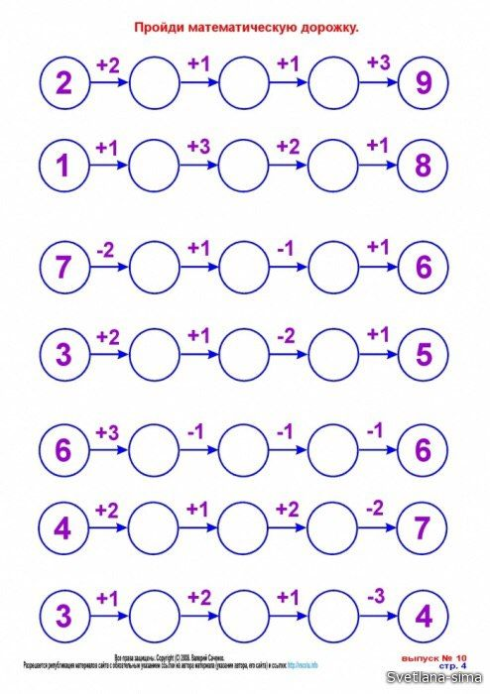

**6․ Դատարկ վանդակները լրացրո՛ւ։**

