**Հաշվի՛ր և գունավորի՛ր:**

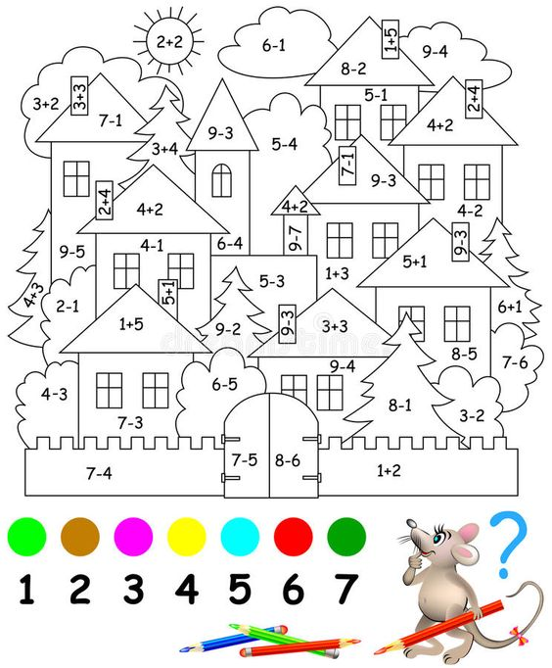

1- կա նա չ 2- շագանակագույն 3-մանուշակագույն

4- դեղին 5- երկնագույն 6-կարմիր 7-կա նա չ

Հաշվի՛ր:

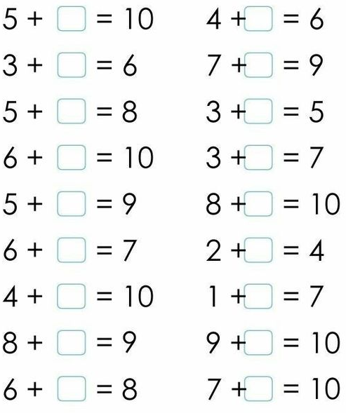

Ճուտիկն ումի 2 ոտք, իսկ ուլիկը՝ 4 ոտք: Քանի՞ ոտք ունեն ճուտիկն ու ուլիկը միասին:

Լուծում

|  |  |  |  |  |
| --- | --- | --- | --- | --- |
|  |  |  |  |  |

|  |
| --- |
|  |

Պատասխան՝

Հաշվի՛ր:

|  |  |  |  |  |  |  |  |  |  |  |  |  |  |  |  |
| --- | --- | --- | --- | --- | --- | --- | --- | --- | --- | --- | --- | --- | --- | --- | --- |
| 1 | + | 1 | = |  |  |  |  | 2 | - | 2 | = |  |  |  |  |
|  |  |  |  |  |  |  |  |  |  |  |  |  |  |  |  |
| 2 | + | 2 | = |  |  |  |  | 4 | - | 2 | = |  |  |  |  |
|  |  |  |  |  |  |  |  |  |  |  |  |  |  |  |  |
| 3 | + | 3 | = |  |  |  |  | 6 | - | 3 | = |  |  |  |  |
|  |  |  |  |  |  |  |  |  |  |  |  |  |  |  |  |
| 4 | + | 4 | = |  |  |  |  | 8 | - | 4 | = |  |  |  |  |
|  |  |  |  |  |  |  |  |  |  |  |  |  |  |  |  |
| 5 | + | 5 | = |  |  |  |  | 1 | 0 | - | 5 | = |  |  |  |

Համեմատի՛ր: < > =

|  |  |  |  |  |  |  |  |  |  |
| --- | --- | --- | --- | --- | --- | --- | --- | --- | --- |
| 1 | + | 1 |  | 3 | - | 1 |  |  |  |
|  |  |  |  |  |  |  |  |  |  |
| 3 | + | 2 |  | 5 | - | 2 |  |  |  |
|  |  |  |  |  |  |  |  |  |  |
| 2 | + | 2 |  | 6 | - | 2 |  |  |  |
|  |  |  |  |  |  |  |  |  |  |
| 5 | - | 3 |  | 3 | + | 7 |  |  |  |

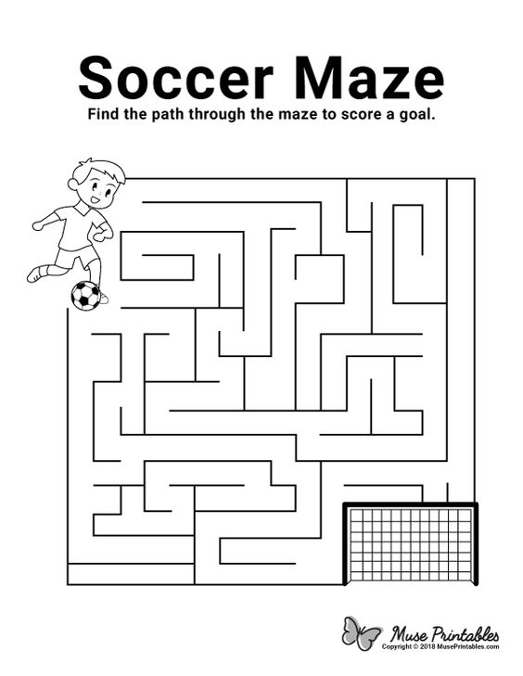

Վերականգնի՛ր վարժությունը:

|  |  |  |  |  |  |  |  |  |  |  |  |  |  |  |  |  |  |  |  |
| --- | --- | --- | --- | --- | --- | --- | --- | --- | --- | --- | --- | --- | --- | --- | --- | --- | --- | --- | --- |
| 2 | + |  | = | 6 |  |  | 6 | + |  | = | 6 |  |  |  |  |  |  |  |  |
|  |  |  |  |  |  |  |  |  |  |  |  |  |  |  |  |  |  |  |  |
| 5 | - |  | = | 4 |  |  | 8 | - |  | = | 4 |  |  |  |  |  |  |  |  |
|  |  |  |  |  |  |  |  |  |  |  |  |  |  |  |  |  |  |  |  |
| 3 | + |  | = | 8 |  |  | 3 | + |  | = | 5 |  |  |  |  |  |  |  |  |
|  |  |  |  |  |  |  |  |  |  |  |  |  |  |  |  |  |  |  |  |
| 8 | - |  | = | 2 |  |  | 7 | - |  | = | 5 |  |  |  |  |  |  |  |  |

Գրի՛ր պակասող թվերը:

|  |  |  |  |  |  |  |  |  |  |  |
| --- | --- | --- | --- | --- | --- | --- | --- | --- | --- | --- |
| 6 | 7 |  |  | 1 | 0 |  |  |  |  |  |
|  |  |  |  |  |  |  |  |  |  |  |
| 1 |  | 3 | 4 |  |  | 7 | 8 | 9 |  |  |
|  |  |  |  |  |  |  |  |  |  |  |
| 4 | 5 |  |  |  |  | 1 | 0 |  |  |  |
|  |  |  |  |  |  |  |  |  |  |  |
| 5 |  |  | 8 | 9 |  |  |  |  |  |  |

Հաշվի՛ր։

|  |  |  |  |  |  |  |  |  |  |  |  |  |  |
| --- | --- | --- | --- | --- | --- | --- | --- | --- | --- | --- | --- | --- | --- |
| 1 | + | 6 | = |  |  |  |  | 7 | - | 6 | = |  |  |
|  |  |  |  |  |  |  |  |  |  |  |  |  |  |
| 2 | + | 5 | = |  |  |  |  | 7 | - | 5 | = |  |  |
|  |  |  |  |  |  |  |  |  |  |  |  |  |  |
| 3 | + | 4 | = |  |  |  |  | 7 | - | 4 | = |  |  |
|  |  |  |  |  |  |  |  |  |  |  |  |  |  |
| 4 | + | 3 | = |  |  |  |  | 7 | - | 3 | = |  |  |
|  |  |  |  |  |  |  |  |  |  |  |  |  |  |
| 5 | + | 2 | = |  |  |  |  | 7 | - | 2 | = |  |  |
|  |  |  |  |  |  |  |  |  |  |  |  |  |  |
| 6 | + | 1 | = |  |  |  |  | 7 | - | 1 | = |  |  |

|  |  |  |  |  |  |  |  |  |  |  |  |  |  |
| --- | --- | --- | --- | --- | --- | --- | --- | --- | --- | --- | --- | --- | --- |
| 1 | + | 7 | = |  |  |  |  | 8 | - | 7 | = |  |  |
|  |  |  |  |  |  |  |  |  |  |  |  |  |  |
| 2 | + | 6 | = |  |  |  |  | 8 | - | 6 | = |  |  |
|  |  |  |  |  |  |  |  |  |  |  |  |  |  |
| 3 | + | 5 | = |  |  |  |  | 8 | - | 5 | = |  |  |
|  |  |  |  |  |  |  |  |  |  |  |  |  |  |
| 4 | + | 4 | = |  |  |  |  | 8 | - | 4 | = |  |  |
|  |  |  |  |  |  |  |  |  |  |  |  |  |  |
| 5 | + | 3 | = |  |  |  |  | 8 | - | 3 | = |  |  |
|  |  |  |  |  |  |  |  |  |  |  |  |  |  |
| 6 | + | 2 | = |  |  |  |  | 8 | - | 2 | = |  |  |
|  |  |  |  |  |  |  |  |  |  |  |  |  |  |
| 7 | + | 1 | = |  |  |  |  | 8 | - | 1 |  |  |  |