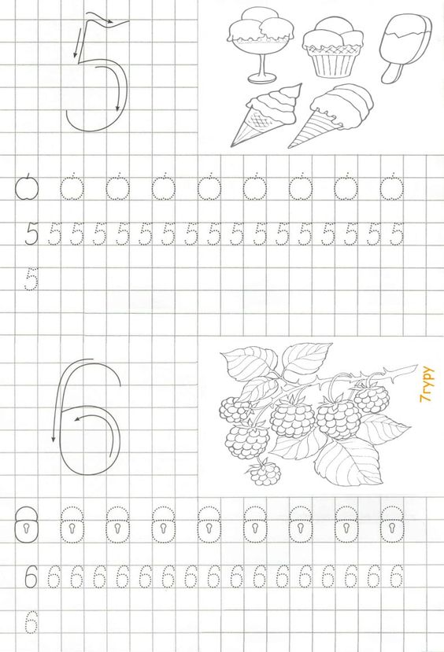

Հաշվի՛ր:

|  |  |  |  |  |  |  |  |  |  |  |  |  |  |  |
| --- | --- | --- | --- | --- | --- | --- | --- | --- | --- | --- | --- | --- | --- | --- |
|  |  |  |  |  |  |  |  |  |  |  |  |  |  |  |
| 1 | + | 4 | = |  |  |  | 5 | - | 1 | = |  |  |  |  |
|  |  |  |  |  |  |  |  |  |  |  |  |  |  |  |
| 2 | + | 3 | = |  |  |  | 5 | - | 2 | = |  |  |  |  |
|  |  |  |  |  |  |  |  |  |  |  |  |  |  |  |
| 3 | + | 2 | = |  |  |  | 5 | - | 3 | = |  |  |  |  |
|  |  |  |  |  |  |  |  |  |  |  |  |  |  |  |
| 4 | + | 1 | = |  |  |  | 5 | - | 4 | = |  |  |  |  |

|  |  |  |  |  |  |  |  |  |  |  |  |  |  |  |
| --- | --- | --- | --- | --- | --- | --- | --- | --- | --- | --- | --- | --- | --- | --- |
|  |  |  |  |  |  |  |  |  |  |  |  |  |  |  |
| 1 | + | 5 | = |  |  |  | 6 | - | 1 | = |  |  |  |  |
|  |  |  |  |  |  |  |  |  |  |  |  |  |  |  |
| 2 | + | 4 | = |  |  |  | 6 | - | 2 | = |  |  |  |  |
|  |  |  |  |  |  |  |  |  |  |  |  |  |  |  |
| 3 | + | 3 | = |  |  |  | 6 | - | 3 | = |  |  |  |  |
|  |  |  |  |  |  |  |  |  |  |  |  |  |  |  |
| 4 | + | 2 | = |  |  |  | 6 | - | 4 | = |  |  |  |  |
|  |  |  |  |  |  |  |  |  |  |  |  |  |  |  |
| 5 | + | 1 | = |  |  |  | 6 | - | 5 | = |  |  |  |  |

Հաշվի՛ր։

|  |  |  |  |  |  |  |  |  |  |  |  |  |  |  |  |  |  |  |  |  |  |  |
| --- | --- | --- | --- | --- | --- | --- | --- | --- | --- | --- | --- | --- | --- | --- | --- | --- | --- | --- | --- | --- | --- | --- |
| 4 | + | 2 | = |  |  |  |  | 5 | - | 3 | = |  |  |  |  | 5 | - | 4 | = |  |  |  |
|  |  |  |  |  |  |  |  |  |  |  |  |  |  |  |  |  |  |  |  |  |  |  |
| 3 | + | 2 | = |  |  |  |  | 6 | - | 2 | = |  |  |  |  | 1 | + | 3 | = |  |  |  |
|  |  |  |  |  |  |  |  |  |  |  |  |  |  |  |  |  |  |  |  |  |  |  |
| 2 | + | 2 | = |  |  |  |  | 4 | - | 1 | = |  |  |  |  | 3 | + | 3 | = |  |  |  |
|  |  |  |  |  |  |  |  |  |  |  |  |  |  |  |  |  |  |  |  |  |  |  |

Հաշվի՛ր:

|  |  |  |  |  |  |  |  |  |  |  |  |  |  |  |
| --- | --- | --- | --- | --- | --- | --- | --- | --- | --- | --- | --- | --- | --- | --- |
|  |  |  |  |  |  |  |  |  |  |  |  |  |  |  |
| 1 | + | 1 | = |  |  |  | 1 | + | 2 | = |  |  |  |  |
|  |  |  |  |  |  |  |  |  |  |  |  |  |  |  |
| 2 | + | 2 | = |  |  |  | 3 | + | 3 | = |  |  |  |  |
|  |  |  |  |  |  |  |  |  |  |  |  |  |  |  |
| 3 | + | 2 | = |  |  |  | 4 | + | 2 | = |  |  |  |  |
|  |  |  |  |  |  |  |  |  |  |  |  |  |  |  |
| 4 | + | 1 | = |  |  |  | 2 | + | 3 | = |  |  |  |  |

|  |  |  |  |  |  |  |  |  |  |  |  |  |  |  |
| --- | --- | --- | --- | --- | --- | --- | --- | --- | --- | --- | --- | --- | --- | --- |
|  |  |  |  |  |  |  |  |  |  |  |  |  |  |  |
| 6 | - | 5 | = |  |  |  | 3 | - | 1 | = |  |  |  |  |
|  |  |  |  |  |  |  |  |  |  |  |  |  |  |  |
| 4 | - | 2 | = |  |  |  | 5 | - | 2 | = |  |  |  |  |
|  |  |  |  |  |  |  |  |  |  |  |  |  |  |  |
| 3 | - | 1 | = |  |  |  | 6 | - | 3 | = |  |  |  |  |
|  |  |  |  |  |  |  |  |  |  |  |  |  |  |  |
| 4 | - | 2 | = |  |  |  | 5 | - | 4 | = |  |  |  |  |
|  |  |  |  |  |  |  |  |  |  |  |  |  |  |  |
| 5 | - | 1 | = |  |  |  | 5 | - | 2 | = |  |  |  |  |

Հաշվի՛ր։

|  |  |  |  |  |  |  |  |  |  |  |  |  |  |  |  |  |  |  |  |  |  |  |
| --- | --- | --- | --- | --- | --- | --- | --- | --- | --- | --- | --- | --- | --- | --- | --- | --- | --- | --- | --- | --- | --- | --- |
| 4 | + | 2 | = |  |  |  |  | 5 | - | 3 | = |  |  |  |  | 5 | - | 4 | = |  |  |  |
|  |  |  |  |  |  |  |  |  |  |  |  |  |  |  |  |  |  |  |  |  |  |  |
| 3 | + | 2 | = |  |  |  |  | 6 | - | 2 | = |  |  |  |  | 1 | + | 3 | = |  |  |  |
|  |  |  |  |  |  |  |  |  |  |  |  |  |  |  |  |  |  |  |  |  |  |  |
| 2 | + | 2 | = |  |  |  |  | 4 | - | 1 | = |  |  |  |  | 6 | - | 3 | = |  |  |  |
|  |  |  |  |  |  |  |  |  |  |  |  |  |  |  |  |  |  |  |  |  |  |  |

Համեմատի՛ր: > < =

|  |  |  |  |  |  |  |  |  |  |  |  |  |  |  |  |  |  |  |  |  |  |  |  |  |
| --- | --- | --- | --- | --- | --- | --- | --- | --- | --- | --- | --- | --- | --- | --- | --- | --- | --- | --- | --- | --- | --- | --- | --- | --- |
| 4 |  | 5 |  |  |  | 5 |  | 4 |  |  |  | 6 |  | 2 |  |  |  | 2 | + | 1 |  | 3 | - | 1 |
|  |  |  |  |  |  |  |  |  |  |  |  |  |  |  |  |  |  |  |  |  |  |  |  |  |
| 2 |  | 1 |  |  |  | 6 |  | 3 |  |  |  | 3 |  | 5 |  |  |  | 5 | - | 2 |  | 1 | + | 2 |

Գտի՛ր թաքնված թիվը:

6

4

51

|  |  |
| --- | --- |
| 1 |  |
|  | 3 |
|  | 2 |
| 4 |  |

|  |  |
| --- | --- |
| 1 |  |
|  | 2 |
| 3 |  |

|  |  |
| --- | --- |
| 1 |  |
|  | 4 |
| 3 |  |
| 4 |  |
|  | 1 |

3

2

|  |  |
| --- | --- |
| 1 |  |

|  |  |
| --- | --- |
| 1 |  |
|  | 2 |

Հաշվի՛ր։

|  |  |  |  |  |  |  |  |  |  |  |  |  |  |  |  |  |  |  |  |  |  |  |
| --- | --- | --- | --- | --- | --- | --- | --- | --- | --- | --- | --- | --- | --- | --- | --- | --- | --- | --- | --- | --- | --- | --- |
| 1 | + | 1 | = |  |  |  |  | 3 | + | 2 | = |  |  |  |  | 6 | - | 3 | = |  |  |  |
|  |  |  |  |  |  |  |  |  |  |  |  |  |  |  |  |  |  |  |  |  |  |  |
| 2 | + | 1 | = |  |  |  |  | 3 | + | 3 | = |  |  |  |  | 6 | - | 4 | = |  |  |  |
|  |  |  |  |  |  |  |  |  |  |  |  |  |  |  |  |  |  |  |  |  |  |  |
| 2 | + | 2 | = |  |  |  |  | 4 | + | 1 | = |  |  |  |  | 6 | - | 5 | = |  |  |  |
|  |  |  |  |  |  |  |  |  |  |  |  |  |  |  |  |  |  |  |  |  |  |  |

|  |  |  |  |  |  |  |  |  |  |  |  |  |  |  |  |  |  |  |  |  |  |  |
| --- | --- | --- | --- | --- | --- | --- | --- | --- | --- | --- | --- | --- | --- | --- | --- | --- | --- | --- | --- | --- | --- | --- |
| 2 | + | 3 | = |  |  |  |  | 4 | + | 2 | = |  |  |  |  | 5 | - | 1 | = |  |  |  |
|  |  |  |  |  |  |  |  |  |  |  |  |  |  |  |  |  |  |  |  |  |  |  |
| 2 | + | 4 | = |  |  |  |  | 6 | - | 1 | = |  |  |  |  | 5 | - | 2 | = |  |  |  |
|  |  |  |  |  |  |  |  |  |  |  |  |  |  |  |  |  |  |  |  |  |  |  |
| 3 | + | 1 | = |  |  |  |  | 6 | - | 2 | = |  |  |  |  | 5 | - | 3 | = |  |  |  |
|  |  |  |  |  |  |  |  |  |  |  |  |  |  |  |  |  |  |  |  |  |  |  |

Հաշվի՛ր։

|  |  |  |  |  |  |  |  |  |  |  |  |  |  |  |  |  |  |  |  |  |  |  |
| --- | --- | --- | --- | --- | --- | --- | --- | --- | --- | --- | --- | --- | --- | --- | --- | --- | --- | --- | --- | --- | --- | --- |
| 5 | - | 4 | = |  |  |  |  | 4 | - | 3 | = |  |  |  |  | 2 | - | 1 | = |  |  |  |
|  |  |  |  |  |  |  |  |  |  |  |  |  |  |  |  |  |  |  |  |  |  |  |
| 4 | - | 1 | = |  |  |  |  | 3 | - | 1 | = |  |  |  |  |  |  |  |  |  |  |  |
|  |  |  |  |  |  |  |  |  |  |  |  |  |  |  |  |  |  |  |  |  |  |  |
| 4 | - | 2 | = |  |  |  |  | 3 | - | 2 | = |  |  |  |  |  |  |  |  |  |  |  |
|  |  |  |  |  |  |  |  |  |  |  |  |  |  |  |  |  |  |  |  |  |  |  |

Համեմատի՛ր: > < =

|  |  |  |  |  |  |  |  |  |  |  |  |  |  |  |  |  |  |  |  |  |  |  |  |  |
| --- | --- | --- | --- | --- | --- | --- | --- | --- | --- | --- | --- | --- | --- | --- | --- | --- | --- | --- | --- | --- | --- | --- | --- | --- |
| 4 |  | 2 |  |  |  | 6 |  | 4 |  |  |  | 1 |  | 6 |  |  |  | 2 | + | 1 |  | 4 | - | 1 |
|  |  |  |  |  |  |  |  |  |  |  |  |  |  |  |  |  |  |  |  |  |  |  |  |  |
| 2 |  | 1 |  |  |  | 2 |  | 5 |  |  |  | 3 |  | 5 |  |  |  | 6 | - | 2 |  | 2 | + | 2 |